Our project, **Period**, is all about turning feminine product vending machines into authentication-based storage boxes that do not need a single penny. This would help save coins and help people, who are undergoing menstruation, to get their needs in one tap. Having Period as an app and infrastructure not only revolutionizes access to feminine hygiene products but also empowers individuals by providing a seamless, dignified experience.

**Key Requirements:**

Minimum Requirements:

* Octa Core
* Android 9.0+ (Pie)
* RAM 4GB

Recommended:

* Octa Core
* Android 11+
* RAM 8GB

Other Requirements:

* Location Permission
* Notification Permission
* Nearby Devices Permission
* Calendar Permission

**Prototype Description**

The prototype was made through Canva, it is not functional at the moment.

[Prototype](https://malayancollegesmindanaoo365-my.sharepoint.com/:f:/g/personal/jdparay_mcm_edu_ph/El2sc1BrlBdGnq9XASqRfKcBLhElZDRfseXt9wpC8ztiLQ?e=NBqixX)

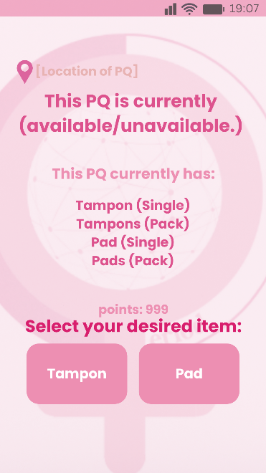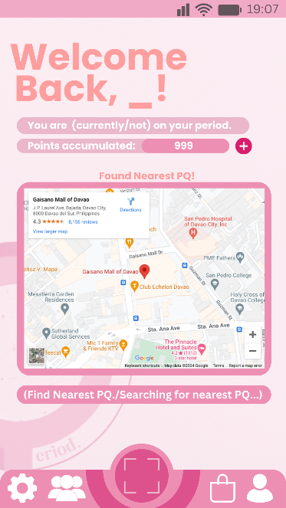

Here, we are showing you the main purpose of Period. The first picture is called the main screen, where the QR Code Scanner is located and other useful tabs. When clicking on the ⸬ logo, you will be seeing the second picture; the QR Scanner. Hypothetically, after scanning a PQ-QR, you will be seeing the last picture, which shows the availability of the PQ, the contents of the PQ, and which item do you wish to get.

**Rationale**

The prototype shown shows a balance between usability and usefulness, it is quite easy to use and easy to understand as it helps a lot of people. The advantages of the product are how useful to find the nearby PQs, plus the main purpose of it on authentication. However, the need for data is a must for this to work, and might not be applicable to people who never use data at all. Nonetheless, it can still be useable with at least a minimal amount of data like how the messenger app works. The minimal data can only work on chatting with other users but unable to scan PQs due to low incoming data.

**Changes To Your Requirements**

We found out that most authentication and QR scanning devices is required to reach at least Android 9.0. Before it was supposed to be 4.4 with a single core, however with further research, it was changed to what it supposed to be.

**Initial Evaluation Plan**

Let users have a survey that shows them how period work and if they will use it when time comes. With these feedbacks from the users, we can be able to add or remove features in the app and PQs to create a more user-friendly application and interaction.